**M language Using Custom Column queries**

M language is the backend of power bi query

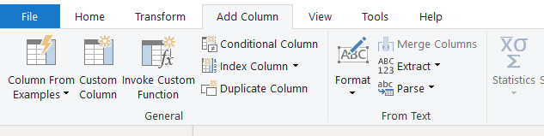

**Click on custom column for adding user’s M language.**

It contains two parts

🡪Let

🡪In

Let contain the source code of the query editor

In is what the user had applied for filters.

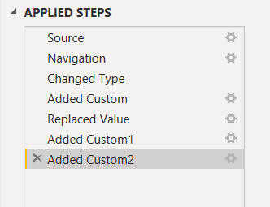

By default first 3 is always present in the right side.

M language has 900+ functions

**Imp note :- If the user want to shart its m language code ,he can just copy it and send to end user ,not need to send the entire power BI**

🡪Date Functions

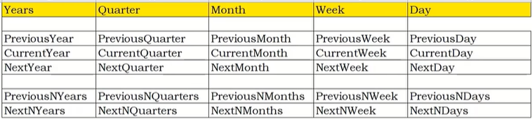

Syntax :

|  |
| --- |
| Date.IsIn.PreviousYear([table_name]) |
| Date.IsIn.PreviousNYear([table_name],no of years) |
| Date.IsIn.NextYear([table_name]) |
| Date.IsIn.NextNYear([table_name],no of years) |
| Date.IsIn.PreviousQuater ([table_name]) |
| Date.IsIn.CurrentYear([table_name]) |
| Date.IsIn.NextMonth([table_name]) |

**Similary for quarter,week,day .**

**M language codes return boolen expression and is dynamic means if you change the data than the boolen expression will also change if it satisfies/doesnot satisfies the condition.**

**Manipulation of date functions**

**🡪Add**

**🡪Subract**

|  |  |
| --- | --- |
| **Date.AddMonths([column_name],** | **no of months)** |
| **Date.AddQuaters([column_name],** | **no of quaters)** |
| **Date.AddWeeks([column_name],** | **no of weeks)** |
| **Date.AddYears([column_name],** | **no of Years)** |
| **Date.AddDays([column_name],** | **no of days)** |

**Similarly for subtraction just ,Subract() instead of Add()**

**🡪Figuring out day ,month, quarter, week , year**

|  |
| --- |
| **Date.Day([column_name])**  **Date.DayOfWeekName([column_name])** |
| **Date.Month ([column_name])**  **Date.MonthName([column_name])** |
| **Date.Year([column_name])** |
| **Date.WeekOfYear([column_name])**  **Date.WeekOfMonth([column_name])** |
| **Date.QuaterOfMonth([Column_name])** |

**Text Functions**

**Text.Upper**

**Text.Lower**

**Text.Proper([column])**

**Text.BeforeDelimiter([column],” “)**

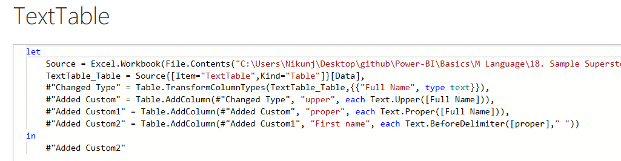

**Automated M Code after using custom query.**